Title OF THE THESIS

<NaME of THE student>



**DEPARTMENT OF ELECTRICAL ENGINEERING**

NED University of Engineering & Technology

2023

“Title OF THE THESIS”

Thesis Submitted in Fulfilment of the Requirements for the Degree of

Masters of Engineering / Masters of Engineering Management

Submitted by:

<**Name in Block Letters**>

<**Roll No.** >

Supervised by:

<**Name in Block Letters**>

<**Designation**>

<**Department**>



**DEPARTMENT OF ELECTRICAL ENGINEERING**

**NED UNIVERSITY OF ENGINEERING & TECHNOLOGY**

<**YEAR**>

**NED UNIVERSITY OF ENGINEERING & TECHNOLOGY**

**ORIGINAL LITERARY WORK DECLARATION**

Name of Candidate: ABC (C.N.I.C/Passport No: 42101-XXX-XX)

Department: Electrical Engineering

Enrolment No.: NED-EE-100054

Name of Degree: Master of Engineering/ Master of Engineering Management

Specialization: Power System/ Control/ Energy Management/

Title of Thesis (“this Work”): MODELLING OF BATTERY ENERGY STORAGE SYSTEM (BESS)

Field of Study: Artificial Intelligence / Power System

I do solemnly and sincerely declare that:

(1) I am the sole author/writer of “this work”;

(2) This work is original;

(3) Any use of any work in which copyright exists was done by way of fair dealing and for permitted purposes and any excerpt or extract from, or reference to or reproduction of any copyright work has been disclosed expressly and sufficiently and the title of the Work and its authorship have been acknowledged in this Work;

(4) I do not have any actual knowledge nor do I ought reasonably to know that the making of this work constitutes an infringement of any copyright work;

(5) I hereby assign all and every rights in the copyright to this Work to the NED University of Engineering and Technology (“NED University”), who henceforth shall be owner of the copyright in this Work and that any reproduction or use in any form or by any means whatsoever is prohibited without the written consent of NED University having been first had and obtained.

Candidate’s Signature Date

Subscribed and solemnly declared before,

Witness’s Signature (Supervisor) Date

Name:

Designation:

ABSTRACT

This study evaluates the effectiveness of carbon dioxide mitigation strategies in reducing greenhouse gas emissions. The study analyzes various carbon dioxide mitigation strategies, including carbon capture and storage, renewable energy, and energy efficiency measures. The study also examines the potential environmental impacts and economic costs associated with these strategies. The research methodology involves a review of existing literature, as well as case studies and simulations to evaluate the effectiveness of different carbon dioxide mitigation strategies. The results of the study indicate that a combination of carbon capture and storage, renewable energy, and energy efficiency measures can significantly reduce greenhouse gas emissions. The study also finds that the potential environmental impacts and economic costs of these strategies vary depending on the specific mitigation approach. Overall, the study suggests that carbon dioxide mitigation strategies can be effective in reducing greenhouse gas emissions and that careful consideration of the potential environmental impacts and economic costs is necessary when implementing these strategies.

Guidelines for writing an abstract:

1. Keep it concise: An abstract should be a brief summary of the thesis, usually between 150-300 words. Make sure to keep the abstract concise and to the point.
2. Follow a structure: The abstract should have a clear structure, including an introduction, methods, results, and conclusion. Make sure that the abstract follows the same structure as the thesis.
3. Use clear language: Avoid using technical jargon or complex terminology in the abstract. Use clear and simple language that is easy to understand for a broad audience.
4. Highlight the main findings: The abstract should highlight the main findings of the thesis. This should include the research question, methods used, and the key results.
5. Avoid new information: Do not include any new information or data that is not already presented in the thesis. The abstract should summarize the main points of the thesis.
6. Edit and proofread: Make sure to edit and proofread the abstract carefully to ensure that it is free of errors and grammatical mistakes.
7. Follow the formatting guidelines: Make sure to follow any formatting guidelines provided by your institution or supervisor, such as font size, spacing, and margin requirements.

ACKNOWLEDGEMENT

This is a template/ guidance only, you need to change the wordings. I would like to express my heartfelt gratitude to all those who have supported and encouraged me throughout the course of this research. I would like to extend my sincere thanks to [Name of Advisor], who has been an inspiration and a constant source of encouragement. Their guidance and expertise have been invaluable in shaping this thesis.

I would also like to thank [Name of Department/Institute], for providing me with the resources and support I needed to complete this study.

I am deeply grateful to my family and friends, who have been my source of strength and motivation throughout this journey. Their love and support have been a constant source of comfort, and I am deeply thankful for their unwavering encouragement.

Finally, I would like to express my gratitude to all the participants who generously gave their time and cooperation, and made this research possible.

Thank you, one and all.

TABLE OF CONTENTS

ABSTRACT iii

ACKNOWLEDGEMENT v

TABLE OF CONTENTS vi

TABLE OF FIGURES ix

LIST OF TABLES x

LIST OF ABBREVIATIONS xi

Chapter 1 INTRODUCTION 1

1.1 Background 1

1.2 Abstract/ Summary 1

1.3 Keywords 1

1.4 Background / Specific Literature Review 1

1.4.1 Dos and Do-not 4

1.5 Problem Statement 5

1.6 Objectives (maximum three objectives and maximum word count of 100 words) 6

1.7 Scope of Work 6

1.8 Methodology (define your tasks as per your objectives) 6

1.9 Beneficiary of the project 9

1.9.1 Direct Beneficiaries: 9

1.9.2 Indirect Beneficiaries: 9

1.10 Sustainable Development Goals (SDGs) 9

1.11 Resources 13

Chapter 2 LITERATURE REVIEW OF ……. 15

2.1 Artificial Intelligence 15

2.1.1 Analytical Methods to Solve Network Reconfiguration Problems 15

2.2 Deep Learning 15

2.3 Smart Grid 15

Chapter 3 PROPOSED METHODOLOGY FOR….. 16

3.1 Proposed Methodology / System for…. 16

3.2 Limitation / Scope of Proposed Methodology 18

Chapter 4 APPLICATIONS OF THE PROPOSED METHOD / RESULTS AND DISCUSSIONS 19

4.1 Test System/ Data Set 19

4.2 Application of proposed method 19

4.3 Results 19

4.4 Analysis / Discussions 19

Chapter 5 CONCLUSION, SDGS AND FUTURE WORK 20

5.1 Conclusion 20

5.2 Research Design and SDG Alignment 21

5.2.1 Objective 1: 22

5.2.2 Objective 2: 22

5.2.3 Objective 3: 22

5.3 Future Work 22

REFERENCES 25

APPENDICES 26

APPENDIX A 26

APPENDIX B 28

APPENDIX C 29

LIST OF FIGURES

Figure 1: Example of a Figure Caption 3

Figure 2: Mapping of Objective (The editable copy of this picture is available on the website eed.neduet.edu.pk) 11

Figure 2: Sustainable Development Goals (SDGs) by United Nations 13

Figure 4: Example of a Figure Caption (The editable copy of this picture is available on the website eed.neduet.edu.pk) 24

LIST OF TABLES

Table 1: Type Styles 11

Table 2: Considerations about the Literature Review 12

Table 3: Resources of the Project 18

LIST OF ABBREVIATIONS

|  |  |
| --- | --- |
| **NEPRA** | National Electric Power Regulatory Authority |
| **DISCOS** | Distribution Companies |
| **AI** | Artificial Intelligence |
| **CNN** | Convolutional Neural Network |
| **EED** | Electrical Engineering Department |
|  |  |
|  |  |
|  |  |
|  |  |

*\*The above is a table without borders. You can add rows. Click on the table, go to Layout at the top right corner. Use Insert Below or Above for adding Rows.*

*This is a table, for your convenience you may switch-n hidden lines of the table, later you must switched them off and follow the template.*

# INTRODUCTION

This chapter describes………

## Background

An abstract is a short summary of a longer work (such as a dissertation or a research paper). The abstract concisely reports the aims, method, and outcomes of your research so that readers know exactly what the research work/paper is about.

## Abstract/ Summary

[maximum 300 words] An abstract is a short summary of a longer work (such as a dissertation or a research paper). The abstract concisely reports the aims, method, and outcomes of your research so that readers know exactly what the research work/paper is about.

## Keywords

Keywords are important words/concepts found in your research question or thesis. A quick way to pull keywords from a proposal/ research question/ thesis is to choose the most important nouns; all other words are irrelevant.

Use at-least three keywords, one keyword at each line, separated with semi-colon (;) for example.

**Protection; Over current relays; Modelling**

## Background / Specific Literature Review

(Use 2000 words maximum excluding tables, captions and equations)

The background has to provide the context of the proposed study. It has to talk about

1. The **broader** research area,
2. What the current literature says about the research area/ research problem,
3. What are some of the gaps in existing studies, and how this led to the gap or need you intend to examine in your study.

The background for a proposal must provide a solid start and foundation to the proposal. Therefore, it helps to cite relevant literature and provide necessary statistics to show why your study is needed.

You can use Figures, Tables and Equations in your literature review.

Be sure that the symbols in your equation have been defined before or immediately following the equation.

Use “Eqn. (1)” to refer equation in the text. Figure 1 to refer figure in the text and Table 1 to refer table in a text. Remember

***All equations must be referred in the text.***

***All figures must be referred in the text.***

***All tables must be referred in the text.***

|  |  |
| --- | --- |
| $${\left(1+x\right)}^{n}=1+\frac{nx}{1!}+\frac{n\left(n-1\right)x^{2}}{2!}+…$$ | Eqn. (1) |

*Hide the table lines (No Borders) once you have done the formatting.

Equation should be centred, and equation no. should be right aligned. It will look like

|  |  |
| --- | --- |
| $${\left(1+x\right)}^{n}=1+\frac{nx}{1!}+\frac{n\left(n-1\right)x^{2}}{2!}+…$$ | Eqn. (1) |

Table 1: Type Styles

| Table Head | Table Column Head | | |
| --- | --- | --- | --- |
| Table column subhead | Subhead | Subhead |
| Copy | More table cop |  |  |

Figure 1: Example of a Figure Caption

All Figures and Tables must be discussed within the text and must be referred in the text before the Figure and Table appeared. This is preferable used cross reference option of Microsoft word For Figure and Table caption.

For Figure and Table caption, please use 10 font size, Times New Roman and bold. Use words rather than symbols or abbreviations when writing Figure axis labels to avoid confusing the reader.

For a good review;

Add journal and conference papers (published in last 5 years)

Add summary tables

Use quantitative results of the papers.

All research papers (published literature) must be new (published within last 5 years).

Use end-note® for citations. Use APA 6th format of citation.

Do not cut paste table and figures of the existing research papers (unless very much necessary).

### Dos and Do-not

Table 2: Considerations about the Literature Review

|  |  |
| --- | --- |
| Dos | Do not |
| Writing a good literature review is an art and this should be coordinated, like a story writing. | Literature review heading should be “Literature review of …..(mention topic)”  e.g. Literature review of voltage stability, Deep learning, standards. |
| The research question should be clear and crisp, preferably one that can be analyzed quantitatively. | All figures and Table must be cited properly. |
| Picking up the right articles is an art, and one should have clear inclusion and exclusion criteria to perform a relevant review. | Do not include irrelevant paper for increasing the number of pages. |
| Citations should be recent and relevant in the current context. | Do not add ranges of papers (e.g. [10-17]) just to increase the number of papers/ references. |
| Citations should include not only those studies with clear-cut outcomes or inferences, but this could also include those papers or articles that are inconclusive or require further research. This is required for better understanding, avoiding bias, and defining further scope for research. | Citations that are old and outdated in the current context are to be avoided. |
| Critical appraisal of the studies cited with an analytical review of the same is to be done. | Bias in citations that intentionally quote only those that are congruent in their conclusions to the current study should be avoided. |
| Adequate number of citations is often defined by the journal and that needs to be followed. | Not weighing the studies under consideration for the quality of research result in inclusion of poor-quality literature that make the outcomes unreliable. |
| Organize and document the data in a format that best suits and justifies the research study. | Too few or too many citations fail to convey the crux in the correct proportions. |
| Read your write up again and again for improvement or give your write up to some relevant person for comments on your write up. | Data organized in a haphazard manner becomes inconclusive and does not interest the reader and sends a wrong message about the quality of the study. |
| Similarity Index must be less than 19%. | Do not copy paste the existing papers or review articles. |

One of the example of citation are as follows, (M. M. Aman, Jasmon, Mokhlis, & Bakar, 2012) (Muhammad Mohsin Aman, Jasmon, Khan, Bakar, & Jamian, 2012) (Kirby & Kang, 2008) (Muhammad Mohsin Aman, Ahmed, & Qazi, 2011).

**For heading, sub-heading-sub-sub-heading do not go more than 3 levels (e.g.**

**1.**

**1.1.**

**1.1.1.**

**If the fourth stage is very much necessary, use *a. b. c. d.* but these numbering (a. b. c. d.) should not be appeared in the ToC (Table of Content).**

All literature review including figure, text and tables must be cited. Use only APA 6th style format (Paithankar & Bhide, 2010).

## Problem Statement

(Not more than 150 words, defining your own problem)

A problem statement is a statement of a current issue or problem that requires timely action to improve the situation. This statement concisely explains the barrier the current problem places between a functional process and/or product and the current (problematic) state of affairs. This statement is completely objective, focusing only on the facts of the problem and leaving out any subjective opinions. To make this easier, it's recommended that you ask who, what, when, where and why to create the structure for your problem statement. This will also make it easier to create and read, and makes the problem at hand more comprehensible and therefore solvable.

## Objectives (maximum three objectives and maximum word count of 100 words)

Objectives specify what the research project proposes to accomplish (do, achieve, estimate, determine, measure, evaluate). In research proposals writing, specific objects are used. Specific objectives are a set or list of sub-objectives, each of which contributes to achieving the general objective.

Objective 1:

Objective 2:

Objective 3:

## Scope of Work

Mention the scope of work or limitation of your proposed work.

## Methodology (define your tasks as per your objectives)

In your proposal, you will have to discuss the methods you will use to do your research. The methodology section should generally be written in the past tense. But in case of synopsis, future tense will be used.

Academic style guides in your field may also provide detailed guidelines on what to include for different types of studies. For example, there are specific guidelines for writing an APA methods section. A single objective can be split into many tasks for formulating the Gantt chart.

Objective 1:

Task 1:

Task 2:

Objective 2:

Task 1:

Task 2:

Objective 3:

Task 1:

Task 2

Note: For the pages you want to keep in Landscape Orientation, create a new section (Layout 🡪 Break🡪 Section Break Next Page). And then change Orientation to Landscape (Layout 🡪 Orientation 🡪 Landscape)

Table 2: Gantt Chart

|  |  |  |  |  |  |  |  |  |
| --- | --- | --- | --- | --- | --- | --- | --- | --- |
|  | **Year 2023** | | | | **Year 2024** | | | |
| **Objectives** | **Jan-Feb** | **March-April** |  |  |  |  |  |  |
| Objective 1 | **To develop a Smart Switch providing time based, unit based and centralized controlling of system** | | | | | | | |
| Task 1 (Proposed) |  |  |  |  |  |  |  |  |
| Task 1 (Actual) |  |  |  |  |  |  |  |  |
| Task 2 (Proposed) |  |  |  |  |  |  |  |  |
| Task 2 (Actual) |  |  |  |  |  |  |  |  |
| Outcome of Objective 1 | Write in your words, what will you achieve after completion of objective 1, which can be gauged. | | | | | | | |
| Objective 2 | **Management of home or industrial appliances by developing the mobile application through which smart switches can be controlled** | | | | | | | |
| Task 1 |  |  |  |  |  |  |  |  |
| Task 2 |  |  |  |  |  |  |  |  |
| Task 3 |  |  |  |  |  |  |  |  |
| Outcome of Objective 2 | Write in words, what will you achieve after completion of objective 2, which can be gauged. | | | | | | | |

Update the proposed Gantt Chart by adding rows under each task to show the actual time taken (highlighted by cross lines).

*Highlight cells, using following steps ….

Press right click of mouse 🡪 Table properties 🡪 Borders and Shading 🡪 Shading 🡪 Black Select 25%

Press right click of mouse 🡪 Table properties 🡪 Borders and Shading 🡪 Borders 🡪 Select Diagonal Lines (both) under Preview

## Beneficiary of the project

Project beneficiaries are those who will derive some benefit from the implementation of the project. Two types of beneficiaries can be defined i.e. direct and indirect.

### Direct Beneficiaries of This Research:

Direct beneficiaries can be defined as those who will participate directly in the project, and thus benefit from its existence. Thus, all persons who will be employed by the project, supply it with raw materials or other goods and services, or who will use in some way the output of the project can be categorised as direct beneficiaries. Some of the examples are consultant, designers, medical doctors, specific industry, students or others.

### Indirect Beneficiaries of This Research:

Indirect beneficiaries are often, but not always, all those living within the zone of influence of the project. For example, a patient in a hospital due to a gadget designed for hospital or a doctor, a driver on a road due to some application designed for traffic management system.

This is preferable that each objective must have some beneficiary and need to be aligned with SDG(s). A conceptual diagram is shown in Figure 2.

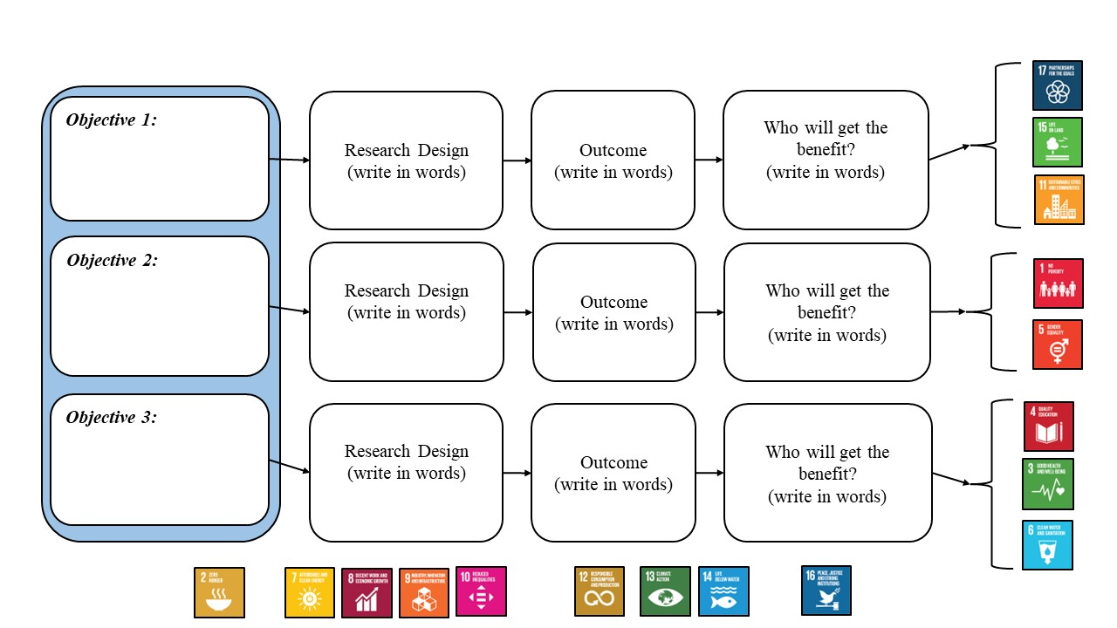

Figure 2: Mapping of Objective (The editable copy of this picture is available on the website eed.neduet.edu.pk)

## Sustainable Development Goals (SDGs)

The Sustainable Development Goals (SDGs) are a set of 17 goals established by the United Nations in 2015 as part of the 2030 Agenda for Sustainable Development. These goals were created to address global challenges related to poverty, inequality, climate change, environmental degradation, and other issues that affect the well-being of people and the planet. The SDGs aim to create a better and more sustainable future for all by balancing economic, social, and environmental sustainability. The 17 SDGs are as follows:

1. No Poverty
2. Zero Hunger
3. Good Health and Well-being
4. Quality Education
5. Gender Equality
6. Clean Water and Sanitation
7. Affordable and Clean Energy
8. Decent Work and Economic Growth
9. Industry, Innovation, and Infrastructure
10. Reduced Inequalities
11. Sustainable Cities and Communities
12. Responsible Consumption and Production
13. Climate Action
14. Life Below Water
15. Life On Land
16. Peace, Justice, and Strong Institutions
17. Partnerships for the Goals

Each SDG has specific targets and indicators that are meant to guide and measure progress towards achieving the goal. The SDGs are meant to be a universal call to action to end poverty, protect the planet, and ensure that all people enjoy peace and prosperity by 2030. The 17 sustainable development goals (SDGs) to transform our world are represented in Figure 2.

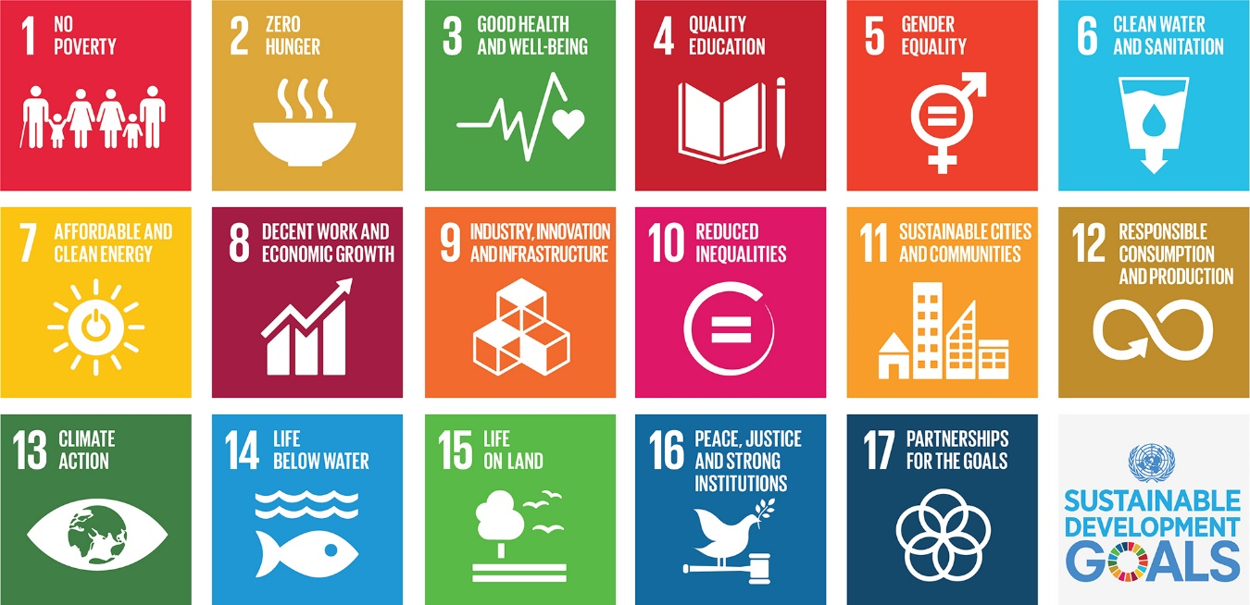

Figure 3: Sustainable Development Goals (SDGs) by United Nations

In this section, select the relevant SDG …

Table 3: Targeted Sustainable Development Goals

|  |  |  |
| --- | --- | --- |
| **GOAL #** | **Sustainable Development Goal (SDG)** | **Selected Goals – Add a ✓** |
| Goal 1 | No Poverty |  |
| Goal 2 | Zero Hunger |  |
| Goal 3 | Good Health and Well-being | **✓** |
| Goal 4 | Quality Education |  |
| Goal 5 | Gender Equality |  |
| Goal 6 | Clean Water and Sanitation |  |
| Goal 7 | Affordable and Clean Energy |  |
| Goal 8 | Decent Work and Economic Growth |  |
| Goal 9 | Industry, Innovation and Infrastructure |  |
| Goal 10 | Reduced Inequality |  |
| Goal 11 | Sustainable Cities and Communities |  |
| Goal 12 | Responsible Consumption and Production |  |
| Goal 13 | Climate Action |  |
| Goal 14 | Life Below Water |  |
| Goal 15 | Life on Land |  |
| Goal 16 | Peace and Justice Strong Institution |  |
| Goal 17 | Partnerships to achieve the Goal |  |

At least 1 SDG should be targeted by your whole overall work or objective wise.

Also explain also how the selected goal will link to your objective/ research work.

Table 4: Justification for SDG selection

|  |  |  |
| --- | --- | --- |
| **Objective #** | **Sustainable Development Goal (SDG)** | **Justification** |
| 1 | Good Health and Well-being | This objective aims …. |
| 1 | Goal 11: Sustainable Cities and Communities | This objective aims …. |
| 2 | Goal 11: Sustainable Cities and Communities | This objective aims …. |

Detailed Guidelines for defining SDGs are given in appendix A-3

## Resources

(covering available resources and required resources- software as well as hardware)

The budget is a representation of the expenses associated with the proposal project. The Budget Justification contains more in-depth detail of the costs behind the line items, and sometimes explains the use of the funds if not evident. Resource details of the project is given in Table 5.

Table 5: Resources of the Project

|  |  |  |  |
| --- | --- | --- | --- |
| **S. No.** | **Item/ Resources** | **Estimated Cost** | **Remarks\*** |
| Available items/ resources | | |  |
| 1. | Hardware, Meters, Software, consultant, Labs |  |  |
| 2. |  |  |  |
| 3. |  |  |  |
| 4. |  |  |  |
| Unavailable Items | | |  |
| 1. | Hardware, Meters, Software, consultant, Labs |  |  |
| 2. |  |  |  |
| 3. |  |  |  |
| 4. |  |  |  |
| 5. | Data gathering (Travelling) |  |  |
|  |  |  |  |

**\*(If resource is available - mention the location where the resource is available.**

**If resource(s) are not available- how will you manage them?)**

The chapter should cover the following:

* Background of the study
* Statement of the problem
* Purpose of the study
* Research questions/hypotheses
* Significance of the study
* Scope and Limitations
* Definition of terms (If there are many definitions, please define in appendix)

# LITERATURE REVIEW OF …….

The chapter reviews the available literature in the context of ……………….. . Section 2.1 describes / discusses overview of relevant literature, theoretical framework, synthesis of previous studies. Are these sub-headings or just structure?

## Artificial Intelligence

### Analytical Methods to Solve Network Reconfiguration Problems

## Deep Learning

## Smart Grid

# PROPOSED METHODOLOGY FOR…..

This chapter describes ………………

## Proposed Methodology / System for….

* Research design
* Participants
* Data collection procedures
* Data analysis methods
  + - 1. *What is a thesis research methodology?*

A thesis research methodology explains**the type of research performed**, **justifies the methods** that you chose by linking back to the [**literature review**](https://www.enago.com/thesis-editing/blog/how-to-write-complete-literature-review-for-your-thesis-dissertation), and describes the **data collection and analysis** procedures.

*What should the research methodology section in your thesis include?*

* The **aim** of your thesis
* An outline of the research methods chosen (**qualitative**, **quantitative**, or **mixed methods**)
* **Background and rationale** for the methods chosen, explaining why one method was chosen over another
* Methods used for **data collection**and **data analysis**
* **Materials and equipment** used—keep this brief
* **Difficulties encountered**during data collection and analysis. It is expected that problems will occur during your research process. Use this as an opportunity to demonstrate your problem-solving abilities by explaining how you overcame all obstacles. This builds your readers’ confidence in your study findings.
* A brief **evaluation of your research** explaining whether your results were conclusive and whether your choice of methodology was effective in practice
  + - 1. *What should not be included in the research methodology section of your thesis?*
* **Irrelevant details**, for example, an extensive review of methodologies (this belongs in the literature review section) or information that does not contribute to the readers’ understanding of your chosen methods
* A description of **basic procedures**
* **Excessive details about materials and equipment used.** If an extremely long and detailed list is necessary, add it as an appendix
* **Raw data- Add to appendix**

The thesis work usually belongs to one of the following types:

* Hardware based
* Simulation Based
* Data analytics/ Survey based (study based)
* Hardware + software
* Design - based on some standards (Drawings)

Based on the nature of work, the different parts of report can focus on different aspects as per need. You may refer to the Table 5 for guidance.

Table 5: Methodology Requirements for the Different Categories of Thesis Work

|  |  |
| --- | --- |
| **Nature of Thesis Work** | **Methodology** |
| Hardware-based Only | The complete design of hardware, components, schematics etc. can be added. The datasheets of components can be added to the appendices. |
| Simulation-based Only | Show simulation results, plots etc. Interpret them and discuss their importance. All graphs or plots must be perfectly labelled and visible. The axes should be labelled. Add legends. |
| Data Analytics / Survey-based | Proposed methodology in the case can be study-based. Qualitative / Quantitative Research  Source of data, how is it collected etc. Different types of plots can be used for data representation. |
| Hardware + Software-based | Divide your description of the proposed-method in 2 parts: Simulation and Hardware.  Also demonstrate the link between the two. |
| Design-based on some Standards | It may include drawings / layouts. Standard details can be added to the appendices. |

## Limitation / Scope of Proposed Methodology

* Please discuss the limitations of the proposed methodology

# APPLICATIONS OF THE PROPOSED METHOD / RESULTS AND DISCUSSIONS

The chapter will cover the application of the proposed method..

## Test System/ Data Set

## Application of proposed method

## Results

* Summary of findings
* Tables and figures/plots to illustrate results

## Analysis / Discussions

* Interpretation of results
* Comparison with previous studies
* Implications of findings

(Will be covered in the next chapter).

# CONCLUSION, SDGS AND FUTURE WORK

The conclusion of a thesis is the final section that ties together the main findings, implications, and contributions of your study.

## Conclusion

**Here's how you can write a conclusion:**

I. Summary of Main Findings:

* Summarize the key results and findings of your study.
* Highlight the contributions and innovations of your work.

II. Implications of Findings:

* Discuss the significance of your results and their implications for theory, practice, or policy.
* Explain how your work contributes to a deeper understanding of the topic.

III. Limitations and Recommendations for Future Research:

* Acknowledge the limitations of your study and suggest areas for improvement.
* Provide recommendations for future research, based on the limitations of your study and the need for further investigation.

IV. Concluding Thoughts:

* Restate the purpose and research questions/hypotheses of your study.
* Emphasize the importance of your work and its contributions to the field.
* Conclude with a final thought or statement that reflects the essence of your study.

Example:

Conclusion

This study aimed to [statement of purpose]. The results have shown that [key findings]. These findings have important implications for [field of study], as they [implications].

The limitations of this study suggest the need for [future research recommendations]. However, despite these limitations, this study has made a significant contribution to the understanding of [topic of study].

In conclusion, this study has [final thought or statement]. It has [contributions to the field] and has [significance]. Further research is needed to [future research recommendations], but this study provides a foundation for continued investigation and advancement in the field.

## Research Design and SDG Alignment

In this section, please provide a brief overview of research design, outcomes, beneficiary and SDG alignment. All the objectives must mention the research design, the outcome and the beneficiary details. Author must mention, how SDGs are linked, although this part will require brainstorming but ultimately the thesis will get weightage.



Figure 4: Mapping of Objective (The editable copy of this picture is available on the website eed.neduet.edu.pk)

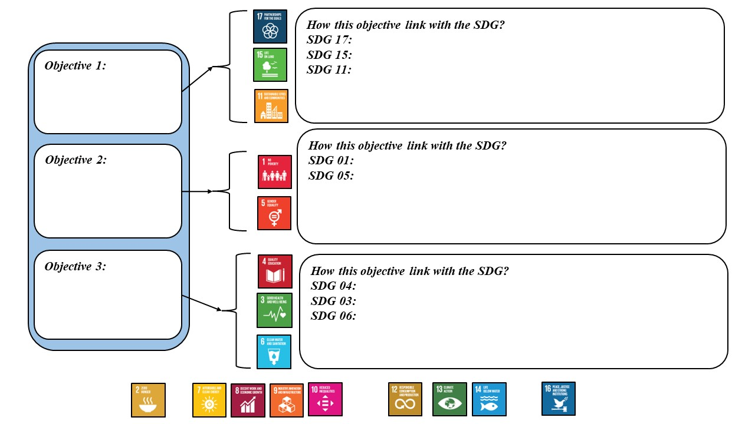

Figure 4: Example of a Figure Caption (The editable copy of this picture is available on the website eed.neduet.edu.pk)

### Objective 1:

Please explain the research design to achieve objective 1, outcome, beneficiary and discuss how this objective link with the SDG(s).

### Objective 2:

Please explain the research design to achieve objective 2, outcome, beneficiary and discuss how this objective link with the SDG(s).

### Objective 3:

Please explain the research design to achieve objective 3, outcome, beneficiary and discuss how this objective link with the SDG(s).

Table: Justification for SDG selection (How?)

|  |  |  |
| --- | --- | --- |
| **Objective #** | **Sustainable Development Goal (SDG)** | **Justification** |
| 1 | Goal 3: Good Health and Well-being | The project/ Objective aims to improve communication and social interaction for people with hearing impairments, which can help to prevent social isolation and improve overall quality of life, aligning with SDG 3.   1. By developing a wearable device that enhances speech, the project can help to increase access to effective communication for people with hearing impairments, which is crucial for achieving SDG 3. 2. The project also has the potential to help prevent cognitive decline in older adults with hearing loss, as research has shown that untreated hearing loss is associated with an increased risk of cognitive decline and dementia. 3. The project may also contribute to reducing stigma associated with hearing impairments, by providing a solution that is discreet and fashionable, thereby encouraging people to use the device without fear of being stigmatized. |
| 2 | Goal 11: Sustainable Cities and Communities | The project/ objective aims to promote sustainable cities and communities by providing reliable and sustainable electricity to urban communities in developing countries, aligning with SDG 11.   1. By integrating renewable energy sources and energy storage systems, the microgrid system can provide a sustainable and reliable source of electricity to urban communities, reducing the reliance on fossil fuels and promoting the use of clean energy. 2. The project may also contribute to improving the quality of life for urban residents by providing a reliable source of electricity for essential services such as healthcare, education, and communication. 3. By promoting the use of clean energy, the project can help to reduce greenhouse gas emissions and promote sustainable economic growth in urban areas. Therefore, this electrical engineering project can be linked to SDG 11 - Sustainable Cities and Communities by providing a sustainable and reliable solution to improve access to electricity in urban communities in developing countries, reduce the reliance on fossil fuels, and promote sustainable economic growth. |

## Future Work

**The "Future Work" section in a thesis provides a roadmap for future research related to the topic of your study. Here's how you can write a future work section:**

I. Introduction:

* Provide a brief overview of the main findings and contributions of your study.
* Explain why further research is necessary.

II. Directions for Future Research:

* Identify specific areas where further research is needed, based on the limitations of your study or gaps in current knowledge.
* Propose new research questions or hypotheses that could be investigated.
* Suggest new methods or approaches that could be used to address these questions.
* Discuss the potential impact and significance of this future work.

III. Conclusion:

* Summarize the key directions for future research.
* Emphasize the importance of continued investigation in this field.
* Express your hope for the future of this area of research and its potential to contribute to a deeper understanding of the topic.

Example:

Future Work

The results of this study have shown that [main findings]. However, there are several limitations that suggest the need for further research. In particular, [limitations of the study].

Future research could address these limitations by [proposed research question/hypothesis]. One approach to doing so could be [new method/approach].

This future work has the potential to [potential impact and significance]. By continuing to investigate this area, we can gain a deeper understanding of [topic of study] and contribute to the advancement of knowledge in this field.

REFERENCES

* Use Endnote for referencing, no other tool will be accepted.
* Use APA 6th style formatting only

Aman, M. M., Ahmed, M. Q., & Qazi, S. A. (2011). Digital Directional and Non-Directional Over Current Relay: Modelling And Performance Analysis. In.

Aman, M. M., Jasmon, G. B., Khan, Q. A., Bakar, A. H. B. A., & Jamian, J. J. (2012). *Modeling and simulation of reverse power relay for generator protection.* Paper presented at the 2012 IEEE International Power Engineering and Optimization Conference (PEOCO) Melaka, Malaysia.

Aman, M. M., Jasmon, G. B., Mokhlis, H., & Bakar, A. H. A. (2012). Optimal placement and sizing of a DG based on a new power stability index and line losses. *International Journal of Electrical Power & Energy Systems, 43*(1), 1296-1304. doi:<https://doi.org/10.1016/j.ijepes.2012.05.053>

Kirby, B., & Kang, H. (2008). MODEL BASED DESIGN FOR POWER SYSTEMS PROTECTION RELAYS, USING MATLAB & SIMULINK. In.

Paithankar, Y. G., & Bhide, S. (2010). *Fundamentals of power system protection*: PHI Learning Pvt. Ltd.

APPENDICES

Additional material relevant to the study, such as raw data, interview transcripts, date tables, pseudocode etc.

APPENDIX A

The proposed method will be applied on following test system, shown in Figure A-1. Note that Figures and Tables of the Appendix will be start from A, i.e. A-1, A-2, A-3 and so on.

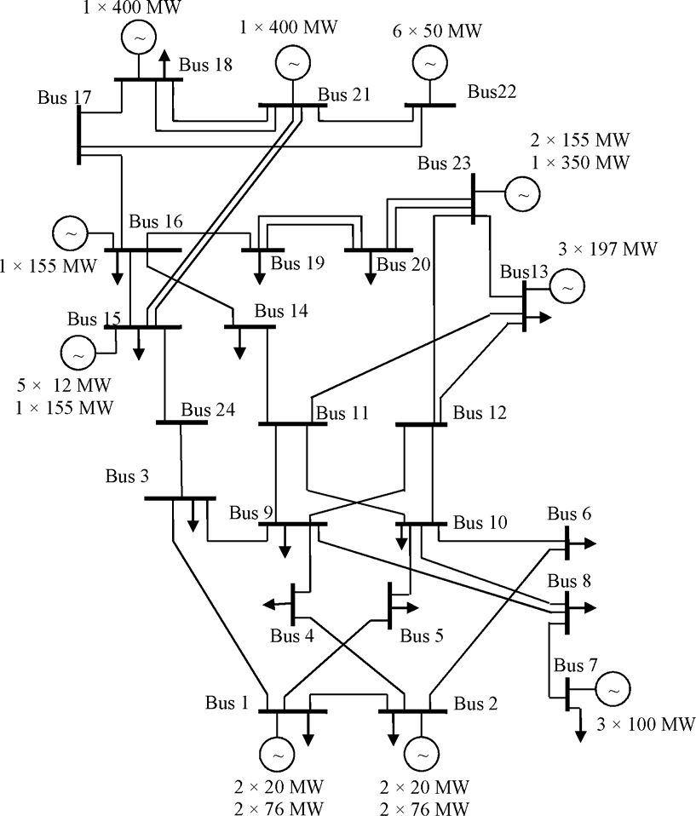

**Figure A-1: Test System IEEE**

APPENDIX B

APPENDIX C

**SUSTAINABLE DEVELOPMENT GOALS**

This chapter will provide some guidelines, examples, and related information on how your research can contribute to achieving the Sustainable Development Goals (SDGs):

1. Identify the relevant SDGs: Before you start your research, identify the SDGs that are relevant to your field of study and the specific topic of your research.
2. Define how your research aligns with the SDGs: Once you have identified the relevant SDGs, clearly define how your research aligns with them. This could involve identifying how your research addresses specific targets or indicators related to the SDGs.
3. Use SDG-related language in your research: Incorporate language related to the SDGs into your research, including in the title, abstract, and introduction. This helps to demonstrate the relevance of your research to sustainable development.
4. Identify the potential impact of your research on the SDGs: Consider how your research could potentially contribute to achieving the SDGs. This could involve identifying the potential benefits of your research, such as improving social, economic, or environmental outcomes.
5. Measure the impact of your research on the SDGs: Use appropriate indicators to measure the impact of your research on the SDGs. This could involve identifying relevant metrics related to the SDGs and tracking progress towards achieving these targets.

Examples:

Here are some examples of how research can contribute to achieving the SDGs:

1. Research on renewable energy technologies can contribute to achieving SDG 7 - Affordable and Clean Energy by providing new and innovative solutions to increase access to renewable energy sources.
2. Research on sustainable agriculture practices can contribute to achieving SDG 2 - Zero Hunger by developing more efficient and sustainable food production systems.
3. Research on urban transportation systems can contribute to achieving SDG 11 - Sustainable Cities and Communities by developing more efficient and sustainable transportation systems that reduce congestion and improve air quality.
4. Research on water treatment and sanitation systems can contribute to achieving SDG 6 - Clean Water and Sanitation by providing access to safe and reliable drinking water and sanitation facilities.

By following these examples, you can ensure that your research contributes to achieving the SDGs and makes a meaningful impact towards sustainable development.

**SDGs and Keywords:**

Here's a brief overview of each SDG and some keywords that can be used to link a research thesis with each goal:

1. No Poverty - This goal aims to eradicate poverty in all its forms and dimensions. Keywords: poverty, inequality, social protection, livelihoods, economic empowerment.
2. Zero Hunger - This goal aims to end hunger, achieve food security, improve nutrition, and promote sustainable agriculture. Keywords: food security, malnutrition, agriculture, rural development, sustainable food systems.
3. Good Health and Well-being - This goal aims to ensure healthy lives and promote well-being for all at all ages. Keywords: healthcare, disease prevention, mental health, access to medicines, health systems strengthening.
4. Quality Education - This goal aims to ensure inclusive and equitable quality education and promote lifelong learning opportunities for all. Keywords: access to education, gender equality in education, educational quality and relevance, teacher training, educational technology.
5. Gender Equality - This goal aims to achieve gender equality and empower all women and girls. Keywords: gender-based violence, women's economic empowerment, equal access to education and healthcare, gender-responsive policies, women's leadership.
6. Clean Water and Sanitation - This goal aims to ensure availability and sustainable management of water and sanitation for all. Keywords: water scarcity, water quality, sanitation, water management, water-related disasters.
7. Affordable and Clean Energy - This goal aims to ensure access to affordable, reliable, sustainable, and modern energy for all. Keywords: renewable energy, energy efficiency, energy access, clean cooking, energy policy.
8. Decent Work and Economic Growth - This goal aims to promote sustained, inclusive, and sustainable economic growth, full and productive employment, and decent work for all. Keywords: job creation, labor rights, entrepreneurship, social protection, economic diversification.
9. Industry, Innovation and Infrastructure - This goal aims to build resilient infrastructure, promote sustainable industrialization, and foster innovation. Keywords: sustainable infrastructure, industrial policy, innovation systems, technological progress, sustainable tourism.
10. Reduced Inequalities - This goal aims to reduce inequalities within and among countries. Keywords: income inequality, social inclusion, anti-discrimination, access to basic services, social protection systems.
11. Sustainable Cities and Communities - This goal aims to make cities and human settlements inclusive, safe, resilient, and sustainable. Keywords: urbanization, sustainable transport, housing, disaster risk reduction, cultural heritage.
12. Responsible Consumption and Production - This goal aims to ensure sustainable consumption and production patterns. Keywords: circular economy, sustainable consumption, eco-design, waste reduction, sustainable procurement.
13. Climate Action - This goal aims to take urgent action to combat climate change and its impacts. Keywords: climate change adaptation, mitigation, renewable energy, climate policy, carbon footprint.
14. Life Below Water - This goal aims to conserve and sustainably use the oceans, seas, and marine resources for sustainable development. Keywords: marine conservation, sustainable fisheries, marine pollution, ocean acidification, marine biodiversity.
15. Life On Land - This goal aims to protect, restore, and promote sustainable use of terrestrial ecosystems, sustainably manage forests, combat desertification, and halt biodiversity loss. Keywords: forest conservation, land degradation, biodiversity conservation, sustainable land use, wildlife conservation.
16. Peace, Justice and Strong Institutions - This goal aims to promote peaceful and inclusive societies, provide access to justice for all, and build effective, accountable, and inclusive institutions at all levels. Keywords: human rights, rule of law, access to justice, accountable institutions, conflict resolution.
17. Partnerships for the Goals - This goal aims to strengthen the means of implementation and revitalize the global partnership for sustainable development. Keywords: multi-stakeholder partnerships, capacity-building, knowledge-sharing, financing for development, technology

**Example related to SDG 1: No Poverty**

**Problem:** Access to reliable and affordable electricity is a major challenge in many rural areas, leading to poverty and economic inequality.

**Solution:** Develop a renewable energy-based microgrid system that provides reliable and affordable electricity to rural communities.

**How the project links to SDG 1 - No Poverty:**

The project aims to provide reliable and affordable electricity to rural communities, which can help to promote economic growth and reduce poverty in these areas, aligning with SDG 1.

1. By using renewable energy sources, the project can help to reduce the reliance on expensive and polluting fossil fuels, which can reduce energy costs and improve economic outcomes for rural communities.
2. The project also has the potential to create employment opportunities in the installation, maintenance, and operation of the microgrid system, which can contribute to reducing poverty and promoting economic development.
3. By providing a sustainable and reliable source of electricity, the project can help to improve access to education, healthcare, and other essential services, which can help to reduce poverty and inequality in rural communities.

Therefore, this electrical engineering project can be linked to SDG 1 - No Poverty by providing a sustainable and reliable source of electricity to rural communities, which can promote economic growth, reduce poverty, and improve access to essential services.

**Example related to SDG 2:**

**Problem:** Many small-scale farmers in developing countries lack access to modern irrigation systems, leading to poor crop yields and food insecurity.

**Solution:** Develop a low-cost, solar-powered irrigation system that can be easily installed and maintained by small-scale farmers in developing countries.

**How the project links to SDG 2 - Zero Hunger:**

The project aims to increase crop yields and promote food security by providing small-scale farmers in developing countries with access to modern irrigation systems, aligning with SDG 2.

1. By using solar power to run the irrigation system, the project can reduce the reliance on fossil fuels and provide a sustainable and affordable solution for small-scale farmers.
2. The project may also contribute to improving soil fertility and reducing soil erosion, by providing a consistent supply of water for crops.
3. By empowering small-scale farmers with modern irrigation technology, the project can help to increase their incomes and improve their livelihoods, which can help to reduce poverty and promote sustainable economic growth.

Therefore, this electrical engineering project can be linked to SDG 2 - Zero Hunger by providing a sustainable and affordable solution to increase crop yields and promote food security for small-scale farmers in developing countries.

**Example related to SDG 3:**

**Problem:** Many people with hearing impairments struggle to effectively communicate with others, leading to social isolation and reduced quality of life.

**Solution:** Develop a wearable device that uses signal processing algorithms to enhance speech and make it easier for people with hearing impairments to understand others.

**How the project links to SDG 3 - Good Health and Well-being:**

1. The project aims to improve communication and social interaction for people with hearing impairments, which can help to prevent social isolation and improve overall quality of life, aligning with SDG 3.
2. By developing a wearable device that enhances speech, the project can help to increase access to effective communication for people with hearing impairments, which is crucial for achieving SDG 3.
3. The project also has the potential to help prevent cognitive decline in older adults with hearing loss, as research has shown that untreated hearing loss is associated with an increased risk of cognitive decline and dementia.
4. The project may also contribute to reducing stigma associated with hearing impairments, by providing a solution that is discreet and fashionable, thereby encouraging people to use the device without fear of being stigmatized.

Therefore, this electrical engineering project can be linked to SDG 3 - Good Health and Well-being by providing a solution to enhance communication and improve social interaction for people with hearing impairments, which can lead to improved quality of life and reduced risk of cognitive decline.

**Example related to SDG 4:**

**Problem:** Many students in developing countries lack access to quality education due to the lack of electricity and internet connectivity.

**Solution:** Develop a solar-powered, internet-connected classroom that provides a reliable source of electricity and internet connectivity to schools in developing countries.

**How the project links to SDG 4 - Quality Education:**

The project aims to improve access to quality education by providing reliable electricity and internet connectivity to schools in developing countries, aligning with SDG 4.

1. By using solar power to run the classroom, the project can provide a sustainable and affordable solution to the lack of electricity in many schools.
2. The project may also contribute to improving the quality of education by providing access to online resources and educational materials, which can enhance the learning experience for students and teachers.
3. By providing an internet-connected classroom, the project can help to bridge the digital divide and promote digital literacy among students in developing countries. Therefore, this electrical engineering project can be linked to SDG 4 - Quality Education by providing a sustainable and affordable solution to improve access to quality education, enhance the learning experience for students and teachers, and promote digital literacy in developing countries.

**Example related to SDG 11: Sustainable Cities and Communities:**

**Problem (related to electrical):** The increasing demand for energy in urban areas is leading to high levels of greenhouse gas emissions and air pollution.

**Solution:** Develop a smart grid system that integrates renewable energy sources and energy storage systems to improve energy efficiency and reduce greenhouse gas emissions in urban areas.

**How the project links to SDG 11 - Sustainable Cities and Communities:**

The project aims to promote sustainable cities and communities by reducing greenhouse gas emissions and air pollution in urban areas, aligning with SDG 11.

1. By integrating renewable energy sources and energy storage systems, the smart grid system can help to reduce the reliance on fossil fuels and promote the use of clean energy in urban areas.
2. The project may also contribute to improving the efficiency of energy distribution and reducing energy waste, by optimizing the use of energy resources and reducing transmission losses.
3. By providing a sustainable and reliable source of energy, the project can improve the quality of life for urban residents and promote sustainable economic growth.

Therefore, this electrical engineering project can be linked to SDG 11 - Sustainable Cities and Communities by providing a sustainable and efficient solution to meet the increasing demand for energy in urban areas, reduce greenhouse gas emissions and air pollution, and promote sustainable economic growth.

**Problem # 2 (related to electrical):** Many urban areas in developing countries suffer from frequent power outages and lack of reliable access to electricity.

**Solution:** Develop a microgrid system that integrates renewable energy sources and energy storage systems to provide reliable and sustainable electricity to urban communities in developing countries.

**How the project links to SDG 11 - Sustainable Cities and Communities:**

The project aims to promote sustainable cities and communities by providing reliable and sustainable electricity to urban communities in developing countries, aligning with SDG 11.

By integrating renewable energy sources and energy storage systems, the microgrid system can provide a sustainable and reliable source of electricity to urban communities, reducing the reliance on fossil fuels and promoting the use of clean energy.

The project may also contribute to improving the quality of life for urban residents by providing a reliable source of electricity for essential services such as healthcare, education, and communication.

By promoting the use of clean energy, the project can help to reduce greenhouse gas emissions and promote sustainable economic growth in urban areas. Therefore, this electrical engineering project can be linked to SDG 11 - Sustainable Cities and Communities by providing a sustainable and reliable solution to improve access to electricity in urban communities in developing countries, reduce the reliance on fossil fuels, and promote sustainable economic growth.

**Example 2:**

Here's an example of how a civil engineering project can be linked to SDG 11 - Sustainable Cities and Communities:

**Problem:** Many urban areas suffer from poor air quality due to the high levels of air pollution from transportation.

**Solution:** Develop a sustainable transportation system that promotes the use of public transportation and reduces the reliance on personal vehicles, such as a Bus Rapid Transit (BRT) system.

**How the project links to SDG 11 - Sustainable Cities and Communities:**

The project aims to promote sustainable cities and communities by reducing air pollution and improving air quality in urban areas, aligning with SDG 11.

1. By promoting the use of public transportation, such as a BRT system, the project can help to reduce the reliance on personal vehicles and promote sustainable transportation in urban areas.
2. The project may also contribute to improving the efficiency of transportation and reducing traffic congestion, by providing a fast and reliable means of transportation for urban residents.
3. By promoting sustainable transportation, the project can help to reduce greenhouse gas emissions and promote sustainable economic growth in urban areas.

Therefore, this civil engineering project can be linked to SDG 11 - Sustainable Cities and Communities by providing a sustainable and efficient solution to reduce air pollution, promote sustainable transportation, and reduce traffic congestion in urban areas.

**Example 3:** Here is an example of a mechanical engineering project that is linked with SDG 11 - Sustainable Cities and Communities:

**Title:** Development of Sustainable Cooling Technologies for Buildings in Urban Areas

**Objective:** The objective of this project is to develop sustainable cooling technologies for buildings in urban areas, with the aim of reducing energy consumption and greenhouse gas emissions while improving indoor comfort levels.

**How it relates to SDG 11:** Sustainable Cities and Communities is about creating livable, inclusive, and sustainable cities and communities. One of the targets of SDG 11 is to improve the energy efficiency of buildings in urban areas. This project contributes to this target by developing sustainable cooling technologies for buildings that can reduce energy consumption and greenhouse gas emissions.

Cooling is a major energy consumer in buildings, especially in urban areas where the urban heat island effect can make it even more challenging to maintain comfortable indoor temperatures. By developing sustainable cooling technologies, this project can help reduce energy demand, decrease carbon emissions, and improve the overall sustainability of urban areas.

Examples of sustainable cooling technologies that could be developed in this project include:

* Passive cooling techniques such as shading, natural ventilation, and green roofs
* High-efficiency air conditioning systems that use renewable energy sources
* Thermal energy storage systems that use off-peak energy to provide cooling during peak demand periods

By developing sustainable cooling technologies for buildings in urban areas, this project can help contribute to SDG 11 by promoting sustainable and energy-efficient urban development.